**Assignment 1: Candidates & Constituencies**

Design the entity class and map xml file for the following table:

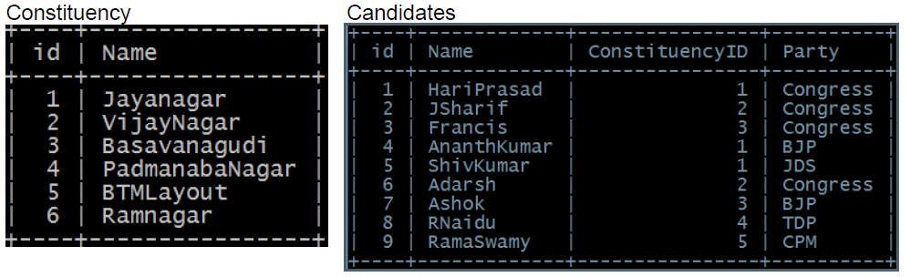

**Do the following**

* Insert the set of candidates contesting in new constituency
* Insert the set of candidates contesting in given constituency ID
* Display candidate name, party, constituency name for the given constituency ID
* Display the candidate name, constituency name for the given party
* Return the set of candidates contesting from the given constituency name
* Display the candidate name for the given party and given constituency name

**Assignment 2: Employee and Department**

**Activity 1**

• Create a Java Project and name it EmpInfoApp.

• Create a configuration file “hiberante.cfg.xml” in “src” folder.

• Configure “hiberante.cfg.xml” with details to connect to mySQL database (employeeDB).

• Create Emplyoee entity class as shown in class diagram.

• Create a hibernate mapping file “Employee.hbm.xml”

* Employee entity should be mapped to EMP table
* employeeNo should be configured as primary key and choose generator as “increment”.

• Add “Employee.hbm.xml” mapping resource in hibernate.cfg.xml

• Write a client application to persist an employee entity using Hibernate session.



**Activity 2**

• To Activity 1 add classes as shown in class diagram to perform CRUD operations on Employee entity class



All DAO methods signature should catch HibernateException and funnel it as com.mindtree.exception.DaoException to the caller application.

**Activity 3**

• To Activity 2 add association as illustrated in class diagram ( A Department can have many employees working in it)



Create mapping file “Department.hbm.xml” and add one-to-many mapping with Employee.

• Add Department.hbm.xml resource to “hibernate.cfg.xml”.

• Create DepartmentDao class to do tasks as shown in diagram:



Application should also assign existing Employee’s [added in activity 2] to a department.

**Activity 4**

• Make the Employee and Department relation bi-directional.

• Retrieve already inserted Employee from database and identify in which Department he works.

• Add a new department with new set of employees, absorb the difference with inverse=“true” attribute for a collection and without it.

• Also persist the entities with and without cascade=“save-update” attribute.

